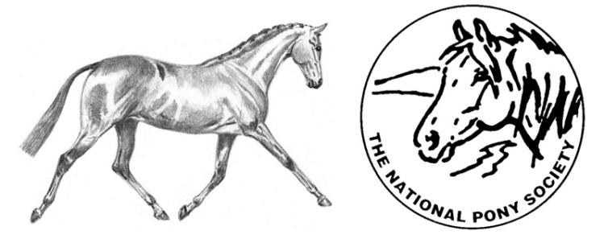
NATIONAL PONY SOCIETY
Education /Training British Riding Pony Competition Bursary
The aim of the bursary is to offer financial assistance of up to £250 to the winner, to access specialist training for a British Riding Pony owner/rider competing in a non-showing discipline. This could include dressage, show jumping, eventing, polo or driving for example.
- Applicants must be aged between 10 and 18 years old on 1st January 2024 and be applying for lessons on a registered NPS British Riding Pony competing in a discipline other than showing.

- Funding may be requested for:
A) A series of lessons with a new instructor, working at a higher level;
B) Cross-discipline tuition (e.g. a dressage rider who wishes to take lessons with an approved eventing instructor);
C) Attendance on a short, intensive course with an approved instructor.

- The instructor will be asked to raise an invoice for their work and funds will be paid direct to the instructor as part or full payment for their time.

- Candidates will be evaluated in December 2023, presentation to be made at the 2024 AGM with funding tranches to be paid throughout 2024.

- The successful candidate will be presented with their bursary at the 2024 AGM and will be asked to write a short report for the 2025 NPS Review, explaining what they did with the funds and how it has benefitted them.
If you are interested, please complete the attached application form, and return it to the NPS Office or email admin@nationalponysociety.com for the attention of Hollie Sanderson by Friday 15th December 2023.

NPS British Riding Pony Competition Bursary Scheme Application Form

Name: ____________________________________________ D.O.B. _____/______/_______
Address: ____________________________________________________________________
___________________________________________________________________________
Telephone: ________________________ Email: ____________________________________
Name of Pony applying for training on: ___________________________________________
I am a current NPS Member My parent/guardian is a current NPS Member
If applicable:
Membership No: __________________Year Joined: _____________ NPS Area: ___________
Name of current instructor(s)/trainer(s): __________________________________________
Name of proposed instructor(s)/trainer(s): __________________________________________
- Please outline your competition experience so far (max 250 words)

- a) If you have had any involvement with the NPS, please provide details below (max 100 words):

b) If you are a member of any other equine society, please provide details:

- Please explain what you would like to use the NPS bursary for and how this would develop your current training and experience (max 250 words)
Type of training  (e.g. Dressage lesson) | Objectives and aims once training is completed  (e.g. Qualify for National Dressage Champs) | How will this be achieved  (e.g. 6 lesson with person X)

- Please indicate the anticipated costs for your proposed training plan. If the NPS bursary is insufficient to cover the costs, please indicate how the shortfall will be met
Training | Cost of Training | Mileage Cost | Total Cost | Short Fall (if any)

Reference 1
Referee cannot be a relative of the applicant or a member of the Council.
Relation to applicant: _________________________________________________________
Name: ____________________________________Occupation:________________________
Telephone: ________________________ Email: ____________________________________
Are you a current member of The National Pony Society? Yes No
Reference: ___________________________________________________________________
____________________________________________________________________________
____________________________________________________________________________
____________________________________________________________________________
____________________________________________________________________________
____________________________________________________________________________
____________________________________________________________________________
____________________________________________________________________________
____________________________________________________________________________
____________________________________________________________________________
Signed: __________________________________________Date: ______________________
Referee 2 – Optional. Referee cannot be a relative of the applicant or a member of the Council.
Relation to applicant: _________________________________________________________
Name: ______________________________________________________________________
Telephone: ________________________ Email: ____________________________________
Are you a current member of The National Pony Society? Yes No
Reference: ___________________________________________________________________
____________________________________________________________________________
____________________________________________________________________________
____________________________________________________________________________
____________________________________________________________________________
____________________________________________________________________________
____________________________________________________________________________
____________________________________________________________________________
Signed: __________________________________________Date: ______________________
Applicant declaration (if aged 18 only)
I declare that the information given is accurate to the best of my knowledge and agree to the society’s terms and conditions.
Print Name: __________________________________________________________________
Signed: ____________________________________ Date: _____________________________

Parent/Guardian of the Applicant declaration
I declare that the information given about _____________ (name) is accurate to the best of my knowledge and agree to the society’s terms and conditions.
Print Name: __________________________________________________________________
Signed: ____________________________________ Date: _____________________________

Please return this form to:
Abbey Fearn
National Pony Society
Arthur Rank Centre
Stoneleigh Park
Warwickshire
CV8 2LG

Should you require any further information please contact the office on 01420 88333 or email admin@nationalponysociety.com
Closing date for applications: Monday 12th December 2022

