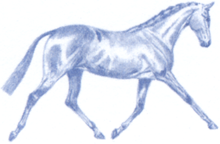
THE NATIONAL PONY SOCIETY
Patron: HRH The Princess Royal
The Arthur Rank Centre, Stoneleigh Park,
Warwickshire, CV8 2LG

admin@nationalponysociety.com www.nationalponysociety.com 01420 88333

NPS WHP JUDGES ASSESSMENT SCHEME
APPLICATION FORM

Your Details:

Title: ______ Initials: ________ Surname: ________________________________ NPS Membership No: _________
(Capitals please)
Address: ______________________________________________________________________________________

__________________________________________________________________________________________________

____________________________________________________________________Post Code _____________________

Tel No: ____________________________________ Mobile No: __________________________________________

Email address: _____________________________________________________________________________________

WHP Panel applied for: M&M or RPB/HPB (Please circle the panel you wish to apply for

Please give any further information that you feel may be helpful to your application on this page and sign.
(Please state why you wish to become an NPS WHP Judge and how much time you would be able to dedicate to this.)

______________________________________________________________________________________________

______________________________________________________________________________________________

______________________________________________________________________________________________

______________________________________________________________________________________________

______________________________________________________________________________________________

______________________________________________________________________________________________

______________________________________________________________________________________________

______________________________________________________________________________________________

______________________________________________________________________________________________

SIGNATURE OF APPLICANT _________________________________________Date____________________

