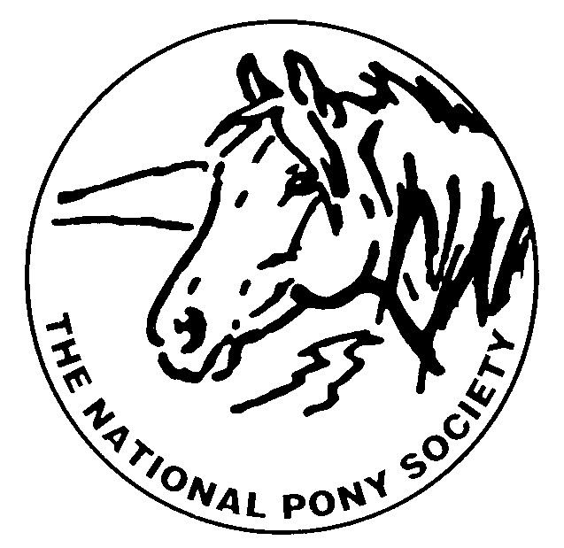
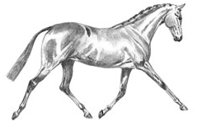
THE NATIONAL PONY SOCIETY
Arthur Rank Centre, Stoneleigh Park, Warwickshire, CV8 2LG
Telephone: 01420 88333 Fax: 01420 80599
Email: admin@nationalponysociety.com
Website: www.nationalponysociety.org.uk

NPS Show Pony & Show Hunter Pony Judges Scheme

This scheme was formed with the co-operation of the British Riding Pony Stud Book Committee which has provided information, help and support. It has been developed to help future judges have a better understanding of the type and the way of going of the Show Pony & Show Hunter Pony. This innovative scheme has been compiled to help educate individuals to increase their knowledge, understanding and ability to judge Show Ponies and Hunter Ponies.

To be eligible the applicant must be 25 years of age or over on 1st January in the year they apply and be a current NPS member

Applications must be supported by nominations from two NPS Senior A Panel judges (one proposer and one seconder) as well as the candidate’s CV. (Please note that A Panel Judges can only support one applicant per year). Applications have to be approved by the NPS and will be reviewed by the Judges Selection Committee. The cost of assessment is £75.00 – a non-refundable deposit of £10.00 must be submitted with the application and the assessment fee of £65.00 must be paid as soon as approval is given.
Please note that candidates cannot apply for more than one panel in the same year.

Stewarding
Candidates are recommended to have experience of stewarding before sending in their application. Please list the shows in which you have experience of stewarding on your CV.

The Assessment Process
There are two parts to the Assessment, both parts must be passed at the same Assessment –

i) Written Rules Questionnaire - The format is a written paper of multiple choice questions based on NPS Rules, General Conformation, Breed Type, and judging situations.

ii) Practical Assessment –Show Ponies & Hunter Ponies will be seen under saddle and in hand. The candidates, as a group, will have time to observe the ponies under show class conditions and make their individual notes. Candidates will then be interviewed individually by the Assessors and asked what they observed about the ponies’ way of going, conformation, and breed standards. Also points about the NPS rules and judging procedures.

Probationary Period
Candidates who pass both parts of the Assessment will then be offered Probationer Judge status. A Probationary Period is required; the number of probations to be completed will depend on past judging experience and the assessment results of the individual candidate. It is a prerequisite that all probationers undertake stewarding duties at either the NPS Spring Festival, The NPS Summer Championships or the NPS Scottish Show, as well as NPS Area Shows, before they will be considered to be elevated onto the B Panel. They are also required to attend NPS conferences and seminars.

Judge Elevations
Probationer Judges are elevated to the B Panel when all their required probations have been completed and received
100% approval from the Senior judges with whom they have been carried out, as indicated on the Senior Judges Report Forms returned to the NPS office.

B Panel Judges may be eligible for elevation to the A Panel upon completion of at least eight affiliated shows over not
less than a two year period.
It is the responsibility of the judge to submit a completed list of shows and classes judged to the NPS Office.
The application to be elevated from B to A Panel will then be considered by the Judges Selection Committee

Annotated Judges may have this removed after two years once they have submitted a list of shows and classes judged to the NPS Office. This will then be considered by the Judges Selection Committee

Please note all applications, recommended probations and elevations are subject to ratification by the NPS Council

