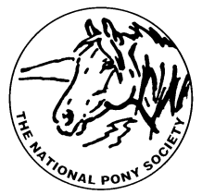
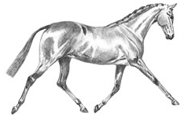
THE NATIONAL PONY SOCIETY
Arthur Rank Centre, Stoneleigh Park, Warwickshire, CV8 2LG
Telephone: 01420 88333 Fax: 01420 80599
Email: admin@nationalponysociety.com
Website: www.nationalponysociety.com

NPS RPB/HPB Working Hunter Pony

This scheme has been developed to encourage judges who are already on the NPS RPB or HPB Panels to come
forward for assessment as RPB/HPB Working Hunter Pony judges. There is a strong demand for Working Hunter
Pony Judges. All judges who are on the NPS RPB or HBP A Panels are eligible to apply. The NPS Judges
Selection Committee would like to persuade as many of these judges as possible to come forward for assessment.
The Assessment Fee is £75.00 and should be sent to the office with the completed application form.

The Assessment Process
This is a practical assessment including the completion of mark sheets. No additional written questionnaire is
involved. A selection of Show Ponies and Show Hunter Ponies will be seen jumping a round of about five WHP
jumps and in hand. The candidates will have time to observe the ponies under show class conditions and complete
the mark sheets. Candidates will then be interviewed individually by the Assessors and asked about the marks they
have given to each pony and what they observed about the pony’s jumping, way of going and conformation.
Appointment to the RPB/HPB Working Hunter Pony Panel
Judges who pass the Assessment will be appointed to the NPS RPB/HPB Working Hunter Pony Probationary
Panel.

How to Apply
Please complete the NPS Judges RPB/HPB Working Hunter Pony Panel Application Form. This can be
downloaded from the NPS website or requested from the NPS office. Please send this to the office with the £75.00
assessment fee. (Cheques should be made payable to the NPS).

Probationary Period
Candidates who pass both parts of the Assessment will then be offered Probationer Judge status. A Probationary Period is required; the number of probations to be completed will depend on past judging experience and the assessment results of the individual candidate. It is a prerequisite that all probationers undertake stewarding duties at either the NPS Spring Festival, The NPS Summer Championships or the NPS Scottish Show, as well as NPS Area Shows, before they will be considered to be elevated onto the B Panel. They are also required to attend NPS conferences and seminars.

Annotated Judges may have this removed after two years once they have submitted a list of shows and classes judged to the NPS Office. This will then be considered by the Judges Selection Committee.
Please note all applications, recommended probations and elevations are subject to ratification by the NPS Council

