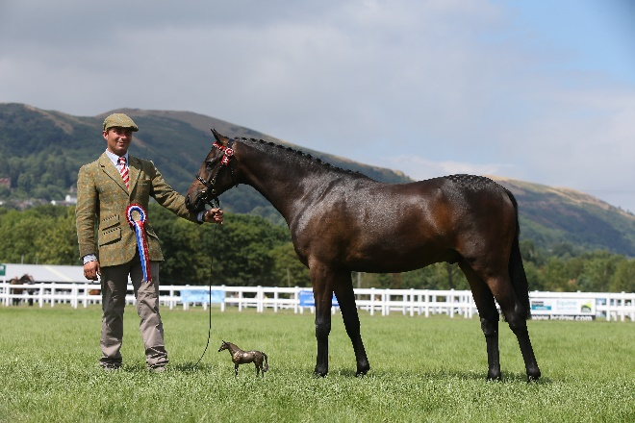

The British Riding Pony Performance Scheme
The objective of this scheme is to promote and recognise the versatility of the British Riding Pony. It is hoped that the wide range of events/classes included will encourage Riding Pony owners to take part.
1. This competition is open to all registered or overstamped British Riding Ponies.
2. Entry forms can be downloaded from the NPS website. Completed entry forms, together with the correct entry fee (cheque or bank transfer) must be sent to the NPS Office.
Entry Fees are £10 for members and £15 for non-members.
On receipt of the entry form and fee, an official results card will be posted.
3. The scheme runs from 1st January to 31st December each year. Entries can be made throughout the year as long as you have kept a record of your results.
Your final completed 2019 results card must be returned to the NPS Office no later than 31st January 2020 as the awards will be made at the NPS AGM in February. No late entries will be accepted.
4. Owners need not be members of the NPS to participate.
5. Ponies are awarded points which are graded according to the activity which range from attending Pony Club games and rallies to competing at Driving Marathons, Long Distance Rides, Hunter Trials or Horse of the Year Show. There truly is something for everyone in this competition.
6. Points that cannot be verified will be disallowed.
7. In hand youngstock must be 3 years and under as of 1st January of the current year.
8. Ponies must gain points in at least 3 sections to qualify for the Overall performance Awards
9. Double points apply to all affiliated competitions excluding showing classes, to include:
British Dressage
British Eventing
British Showjumping
British Driving
Plus Double Points for all NPS Area Events
10. Bonus Points for winning championships, team selection and qualifying for certain Finals.

11. Any pony sold during the Competition Year may have points gained before sale transferred to the new owner on application.
12. Rosettes to 10th place in each section.
Section 1 - Dressage | 1st | 2nd | 3rd | 4th | 5th | 6th
Intro – Novice | 80 | 60 | 40 | 30 | 20 | 10
Elementary & above | 100 | 80 | 60 | 50 | 40 | 30
Driven Dressage | 100 | 80 | 60 | 50 | 40 | 30
Remember to DOUBLE your points for affiliated competitions
Section 2 – Jumping | 1st | 2nd | 3rd | 4th | 5th | 6th
One Day Event | 250 | 230 | 210 | 190 | 170 | 150
Arena Eventing | 100 | 80 | 60 | 40 | 30 | 20
Hunter Trials | 100 | 80 | 60 | 40 | 30 | 20
Dressage with jumping | 150 | 120 | 100 | 80 | 60 | 40
Show Jumping- Novice up to 60cm | 60 | 50 | 40 | 30 | 20 | 10
Show Jumping – 70cm + | 80 | 60 | 40 | 30 | 20 | 10
Remember to DOUBLE your points for affiliated competitions
Section 3 – Ridden Showing | 1st | 2nd | 3rd | 4th | 5th | 6th
Working Hunter Pony | 100 | 80 | 60 | 40 | 30 | 20
Leading Rein Show Class | 80 | 60 | 50 | 40 | 30 | 20
First Ridden Show Class | 80 | 60 | 50 | 40 | 30 | 20
Other Ridden Show Class | 80 | 60 | 50 | 40 | 30 | 20
Private Driving | 100 | 80 | 60 | 40 | 30 | 20
Remember to DOUBLE your points for NPS Area Shows
Section 4 – In Hand Showing | 1st | 2nd | 3rd | 4th | 5th | 6th
Riding Pony/ Hunter Pony Breeding | 100 | 80 | 60 | 50 | 40 | 30
Sport Pony in hand | 80 | 60 | 40 | 30 | 20 | 10
Part bred in hand | 60 | 50 | 40 | 30 | 20 | 10
Section 5 - Utility | 1st | 2nd | 3rd | 4th | 5th | 6th
Hunting 3 hours or more | 80
Mounted Games (Max 4 in one day) | 15 | 12 | 10 | 8 | 6 | 4
Trec | 60 | 50 | 40 | 30 | 20 | 10
Long Distance Rides | 20kms+  200 | 15-20kms 150 | 10-15kms 100 | 5-10kms 50
Driving Trials | 200 | 150 | 100 | 50 | 40 | 30
Pony Racing | 200 | 150 | 100 | 50 | 40 | 30

BONUS POINTS SECTION
Section Champion | 50
Section Reserve Champion | 25
Supreme of Show | 150
Reserve Supreme of Show | 75
Qualification for HOYS/RIHS | 100
Qualification for NPS Summer Championships | 60
Qualification for NPS Dressage Championships | 50
Qualification for BD Area Festivals | 50
Qualification for BD Regionals | 100
Qualification for BE Grassroots Final | 100
Qualification for BS National Championships | 100
Selected for Pony Club/Riding Club Area Teams | 100
Attending 2/3 day Pony/Riding Club Camp | 50

FABULOUS PRIZES TO BE ANNOUNCED IN THE NEW YEAR.
FOLLOW US ON FACEBOOK AND INSTAGRAM TO KEEP UP TO DATE WITH ALL THE PERFORMANCE NEWS
REGISTER YOUR INTEREST TODAY

