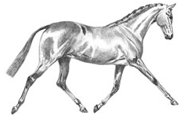
BRITISH RIDING PONY PERFORMANCE SCHEME
2019 ENTRY FORM

OWNER’S NAME

ADDRESS

TELEPHONE

EMAIL

NPS MEMBERSHIP NUMBER (if applicable)
NAME OF PONY

PASSPORT NUMBER

Please return your form, together with a payment of either £10 (if the Owner is an NPS member) or £15 for non-members to:
The National Pony Society
Arthur Rank Centre
Stoneleigh Park
Warwickshire
CV8 2LG

Card payments can be made by phoning 01420 88333

