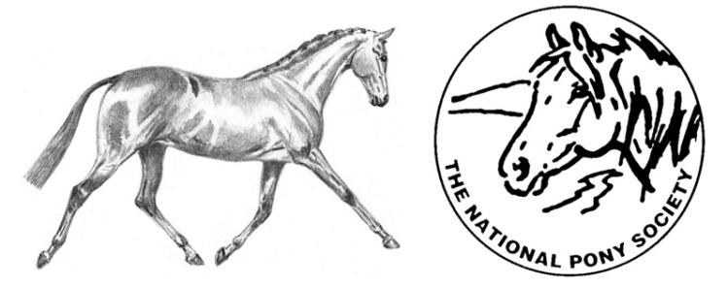
NATIONAL PONY SOCIETY
Education /Training Bursary
The aim of the bursary is to offer financial assistance to access specialist training for up to the sum of £250.00.
- Applicants must be aged between 10 and 18 years old on 1st January 2019 and be a current NPS member in their own right or their parent/guardian must be a member.

- Funding may be requested for:
A) A series of lessons with a new instructor, working at a higher level;
B) Cross-discipline tuition (e.g. a WHP rider who wishes to take lessons with an approved eventing instructor);
C) Attendance on a short, intensive course with an approved instructor.

- The instructor will be asked to raise an invoice for their work and funds will be paid direct to the instructor as part or full payment for their time.

- Candidates will be evaluated in November – December 2018, presentation to be made at the 2019 AGM with funding tranches to be paid throughout 2019.

- The successful candidate will be presented with their bursary at the 2019 AGM and will be asked to write a short report for the 2019 NPS Review, explaining what they did with the funds and how it has benefitted them.
If you are interested, please complete the attached application form and return it to the NPS Office for the attention of Heather Abrahall by Friday, 26th October 2018.

NPS Bursary Scheme Application Form

Name: ____________________________________________ D.O.B. _____/______/_______
Address: ____________________________________________________________________
___________________________________________________________________________
Telephone: ________________________ Email: ____________________________________
I am a current NPS Member My parent/guardian is a current NPS Member

Membership No: __________________Year Joined: _____________ NPS Area: ___________
Name of current instructor(s)/trainer(s): __________________________________________

- Please outline your ridden or in hand experience so far (max 250 words)

- Please outline your involvement with the NPS at both national and area level (e.g assisting at area shows, member of area or national teams) (max 250 words)

- Please explain what you would like to use the NPS bursary for and how this would develop your current training and experience (max 250 words)

- Please indicate the anticipated costs for your proposed training plan. If the NPS bursary is insufficient to cover the costs, please indicate how the shortfall will be met
(e.g. Cost of Lessons x 3 = £x
Travel costs to lessons x 3 = £y
Total: £ with shortfall to be covered by own
resources / parental contribution.)

Optional Reference.
Referee cannot be a relative of the applicant or a member of the Council.
Referee 1
Name: ______________________________________________________________________
Telephone: ________________________ Email: ____________________________________
Are you a current member of The National Pony Society? Yes No
Reference: ___________________________________________________________________
____________________________________________________________________________
____________________________________________________________________________
____________________________________________________________________________
____________________________________________________________________________
____________________________________________________________________________
____________________________________________________________________________
____________________________________________________________________________
____________________________________________________________________________
____________________________________________________________________________
Signed: __________________________________________Date: ______________________
Referee 2
Name: ______________________________________________________________________
Telephone: ________________________ Email: ____________________________________
Are you a current member of The National Pony Society? Yes No
Reference: ___________________________________________________________________
____________________________________________________________________________
____________________________________________________________________________
____________________________________________________________________________
____________________________________________________________________________
____________________________________________________________________________
____________________________________________________________________________
____________________________________________________________________________
____________________________________________________________________________
Signed: __________________________________________Date: ______________________
Applicant declaration (if aged 18 only)
I declare that the information given is accurate to the best of my knowledge and agree to the society’s terms and conditions.
Print Name: __________________________________________________________________
Signed: ____________________________________ Date: _____________________________

Parent/Guardian of the Applicant declaration
I declare that the information given about _____________ (name) is accurate to the best of my knowledge and agree to the society’s terms and conditions.
Print Name: __________________________________________________________________
Signed: ____________________________________ Date: _____________________________

Please return this form to:
Heather Abrahall
National Pony Society
Arthur Rank Centre
Stoneleigh Park
Warwickshire
CV8 2LG

Should you require any further information please contact the office on 01420 88333 or email admin@nationalponysociety.com
Closing date for applications: Friday 26th October 2018

