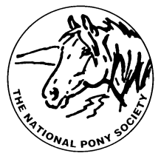
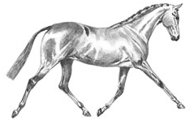
THE NATIONAL PONY SOCIETY
Arthur Rank Centre, Stoneleigh Park, Warwickshire, CV8 2LG
Telephone: 01420 88333 Fax: 01420 80599
Email: admin@nationalponysociety.com
Website: www.nationalponysociety.com

NPS Mountain & Moorland Working Hunter Pony

This scheme has been set up with the co-operation of all the Native Breed Societies who have provided information,
help and support. It has been developed to encourage judges who are already on the NPS Mountain and Moorland
Panel to come forward for assessment as M&M Working Hunter Pony judges. There is a strong demand for
Working Hunter Pony Judges. All judges who are on the NPS Mountain and Moorland A Panel are eligible to apply.
The NPS Judges Selection Committee would like to persuade as many of these judges as possible to come forward
for assessment. The Assessment Fee is £75.00 and should be sent to the office with the completed application form.

The Assessment Process
This is a practical assessment including the completion of mark sheets. No additional written questionnaire is
involved. A selection of Mountain and Moorland ponies will be seen jumping a round of about five WHP jumps
and in hand. The candidates will have time to observe the ponies under show class conditions and complete the mark
sheets. Candidates will then be interviewed individually by the Assessors and asked about the marks they have given
to each pony and what they observed about the pony’s jumping, way of going and conformation.

Appointment to the M&M Working Hunter Pony Panel
Judges who pass the Assessment will be appointed to the NPS M&M Working Hunter Pony Probationary Panel.

How to Apply
Please complete the NPS Judges M&M Working Hunter Pony Panel Application Form. This can be downloaded
from the NPS website or requested from the NPS office. Please send this to the office with the £60.00 assessment
fee. (Cheques should be made payable to the NPS).

Probationary Period
Candidates who pass both parts of the Assessment will then be offered Probationer Judge status. A Probationary Period is required; the number of probations to be completed will depend on past judging experience and the assessment results of the individual candidate. It is a prerequisite that all probationers undertake stewarding duties at either the NPS Spring Festival, The NPS Summer Championships or the NPS Scottish Show, as well as NPS Area Shows, before they will be considered to be elevated onto the B Panel. They are also required to attend NPS conferences and seminars.

Annotated Judges may have this removed after two years once they have submitted a list of shows and classes judged to the NPS Office. This will then be considered by the Judges Selection Committee.
Please note all applications, recommended probations and elevations are subject to ratification by the NPS Council

